PROPER-T-ESTATE

A PROPERTY MANAGEMENT WEB APPLICATION

GitHub : <https://github.com/ganeshreddy824/Proper-T-Estate>

1. **TITLE**

Online Property Management Application

1. **DESCRIPTION**
   1. **OVERVIEW**

An online property management application offers seamless user and admin authentication for secure access. Users can explore a diverse range of properties including flats, lands, apartments, houses, and PG accommodations. Meanwhile, admins possess comprehensive control, able to both add and review all listed properties. With our robust email confirmation system, users and admins receive verification links, ensuring a secure and efficient communication channel.

* 1. **KEY FEATURES**
  2. **Landing/Home Page**

The landing/home page serves as the entry point to a website or application. It typically provides an overview of the site's purpose and often includes navigation elements to guide users to other pages within the site.

* 1. **Property Selection Page**

The property selection page is a specific page where users can browse and view available property amenities as Type, Price, Area, Address, Measurements, Image etc.

* 1. **View Property Page**

The view property page provides information about property

facilities as security, water supply, power etc

* 1. **Contact Agent**

The Contact agent section provide some basic contact information about the agent.

* 1. **Login Page**

The login page is where users can enter their credentials (such as gmail and password) to gain access to restricted areas of the website or application. It verifies the user's identity before granting access.

* 1. **Signup Page**

The sign-up page allows new users to create an account on the website or application. It typically requires users to provide some personal information, such as their name, email address, and a chosen password.

* 1. **Admin Page**

The admin page provides features for managing the properties and property amenities, such as add property amenities as Type, Price, Area, Address, Measurements, Image, view property, edit property, delete property and view properties.

* 1. **Profile Page**

The Profile page provides the user basic information.

1. **PARTICIPANTS AND ROLES**

**1) Ganesh Reddy Gangireddygari** – ROLE Full Stack

My role in the project focused on both frontend and backend development. Leveraging my expertise in ReactJS, React Bootstrap, Spring Boot and MySQL. Integrated email confirmation feature ensures transparent communication, with both users and admins receiving verification links for added security. I ensured that the all components were efficiently implemented, providing a smooth, responsive user experience and email confirmation.

**2) Vinay Kumar Perumalla** – ROLE UI and Full Stack

My role in the project primarily focused on frontend development and UI design. I was responsible for creating intuitive user interfaces that were both visually appealing and user-friendly and resource gathering. Leveraging my expertise in React JS and React Bootstrap, Spring boot and MySQL. I ensured that the frontend components were efficiently implemented, providing a smooth and responsive user experience.

**3) Venkata Sumanth Gopishetty** – ROLE Frontend and Backend

My role in the project focused on frontend development and backend development. Leveraging my expertise in React JS, Spring Boot and MySQL, I ensured that the all components were efficiently implemented, providing a smooth and responsive user experience.

**4) Abdul Khadar Zilan Kothakota** – ROLE Frontend and Backend

My role in the project focused on frontend development and backend development. Leveraging my expertise in React JS, Spring Boot and MySQL, I ensured that the all components were efficiently implemented, providing a smooth and responsive user experience.

.

**5) Sasikiranmai Iravaraju** – ROLE Frontend and Backend

My role in the project focused on frontend development and backend development. Leveraging my expertise in React JS, Spring Boot and MySQL, I ensured that the all components were efficiently implemented, providing a smooth and responsive user experience.

**6) Vikashini** – ROLE Frontend and Backend

My role in the project focused on frontend development and backend development. Leveraging my expertise in React JS, Spring Boot and MySQL, I ensured that the all components were efficiently implemented, providing a smooth and responsive user experience.

**7) Manjunath Kotakonda** – ROLE Frontend and Backend

My role in the project focused on frontend development and backend development. Leveraging my expertise in React JS, Spring Boot and MySQL, I ensured that the all components were efficiently implemented, providing a smooth and responsive user experience.

1. **SCREENSHOTS**
2. **Landing Page**

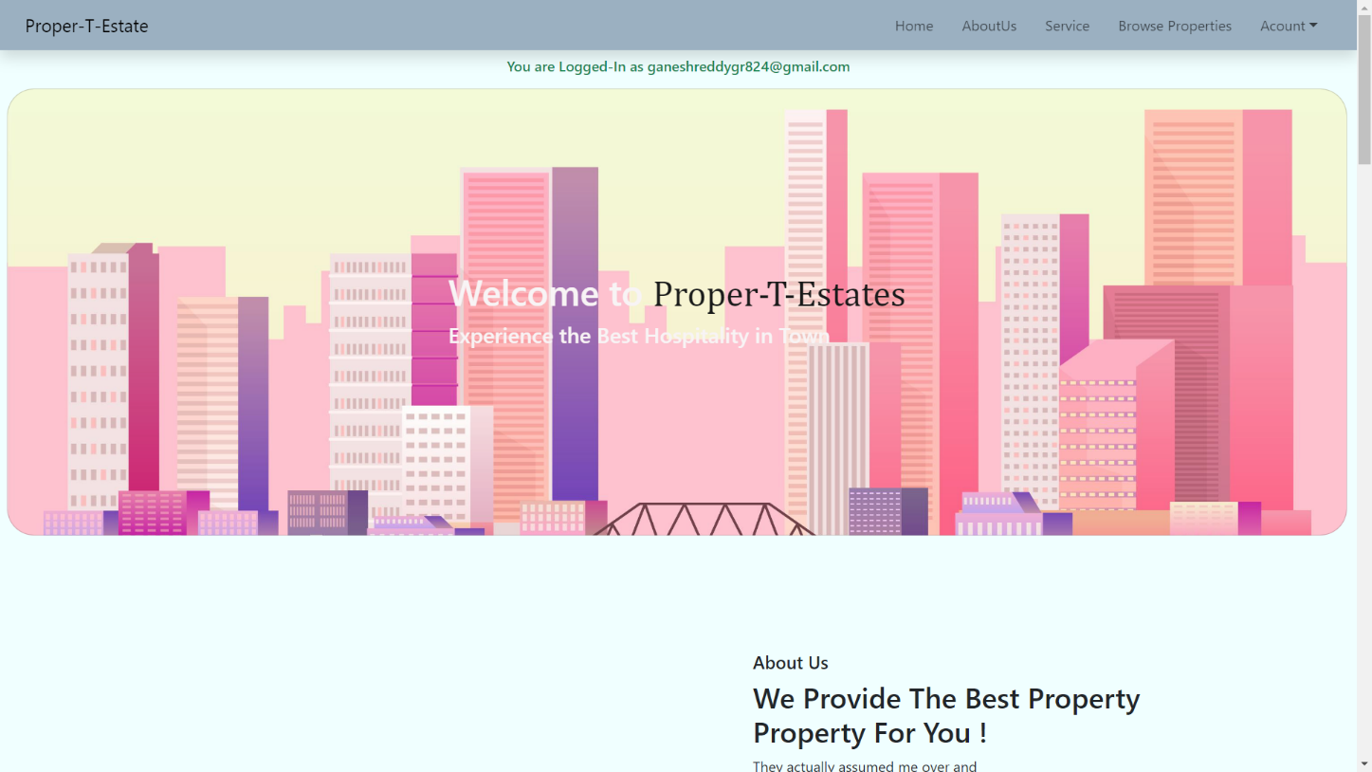

1. 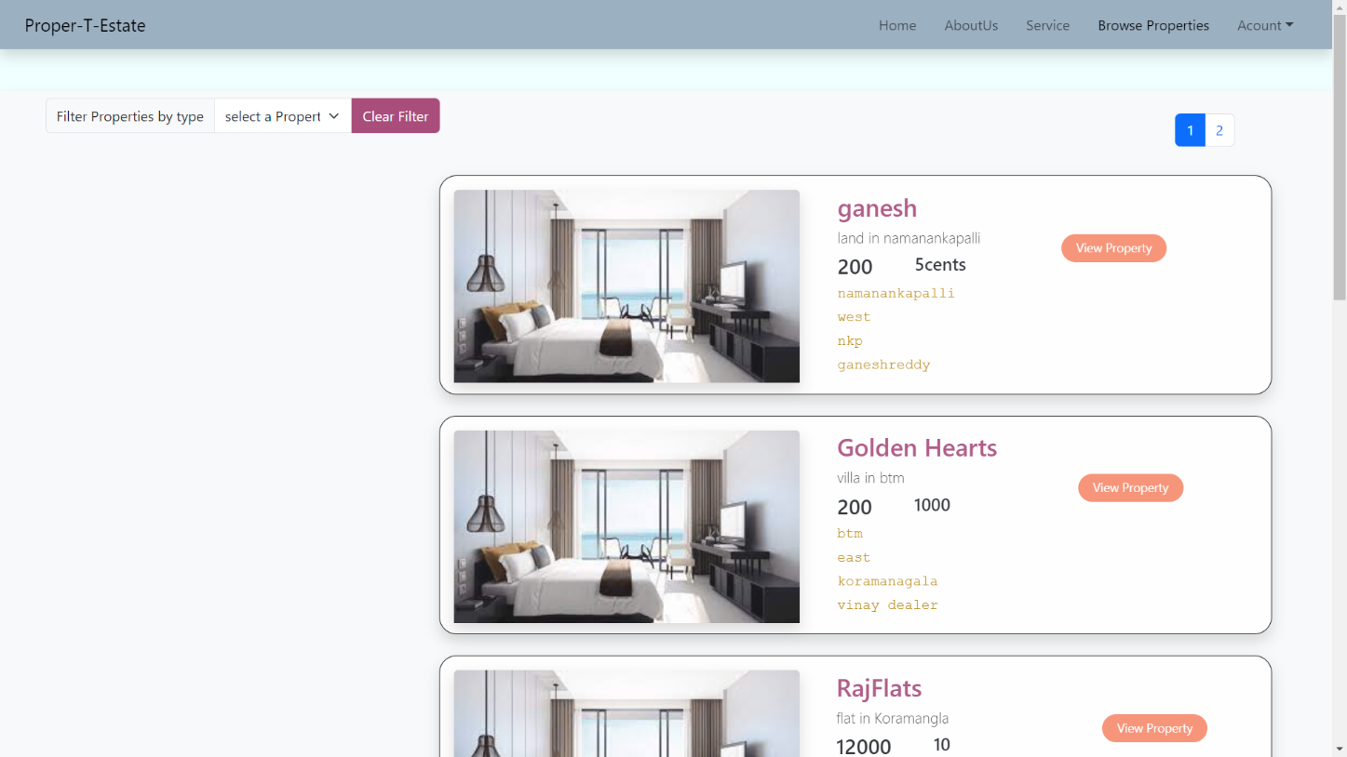**Property Selection Page**
2. **View Property Page**

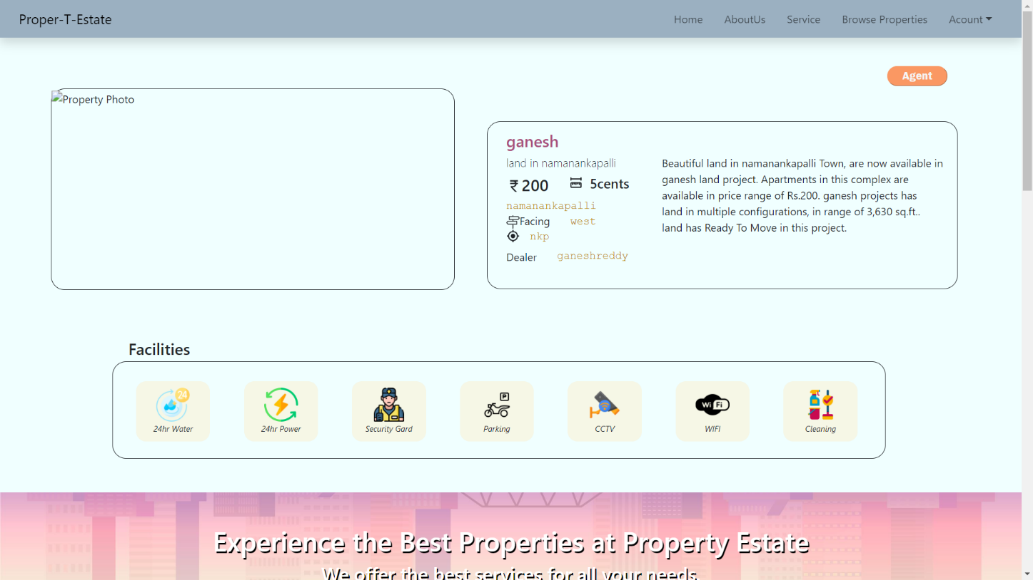

1. **Contact Agent**

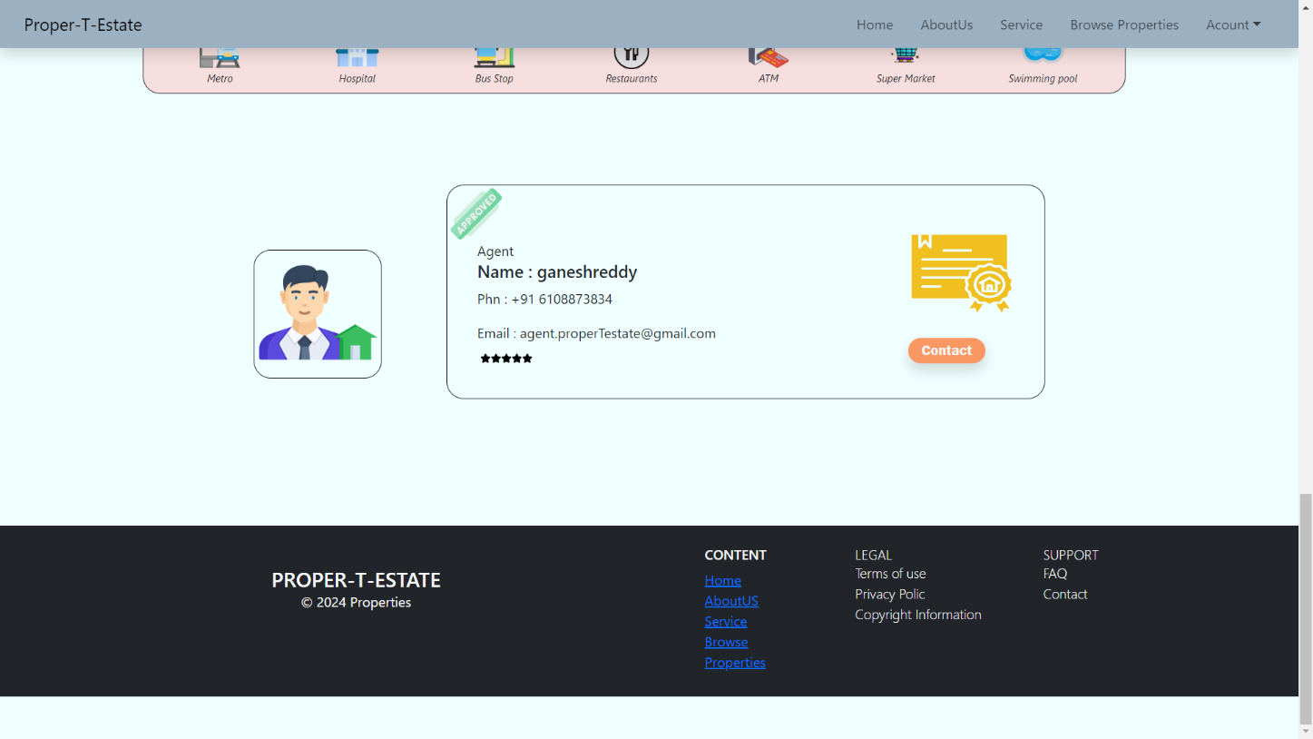

* **Agent appointment**

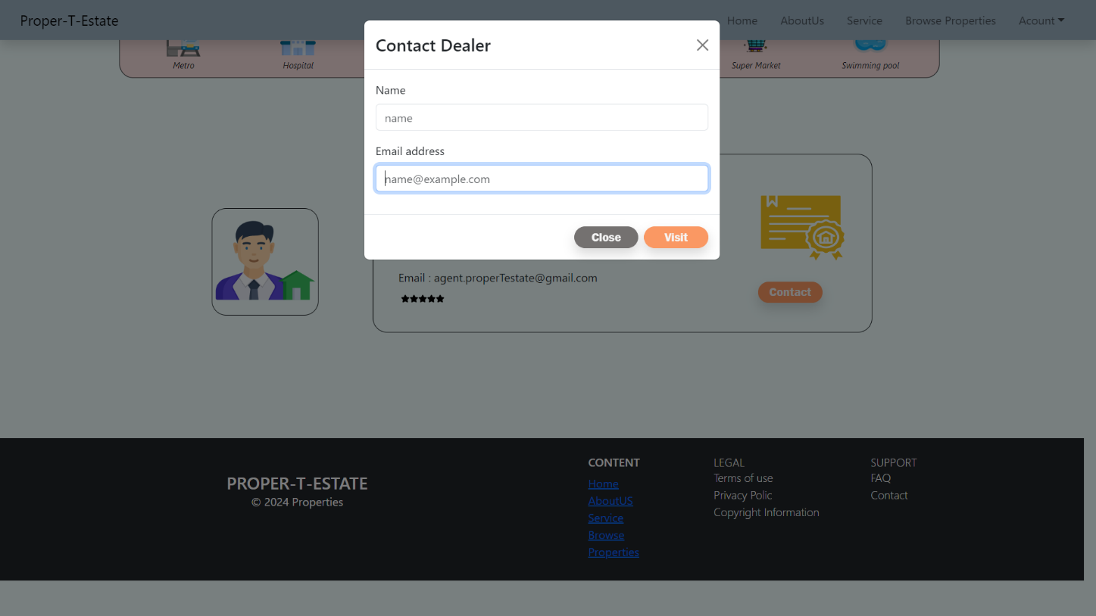

**e) Login Page**

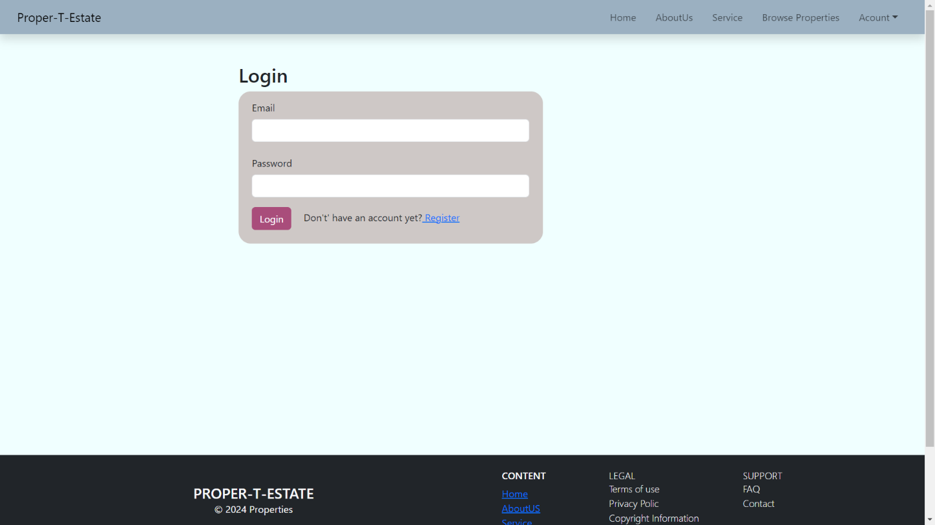

**f) Register Page**

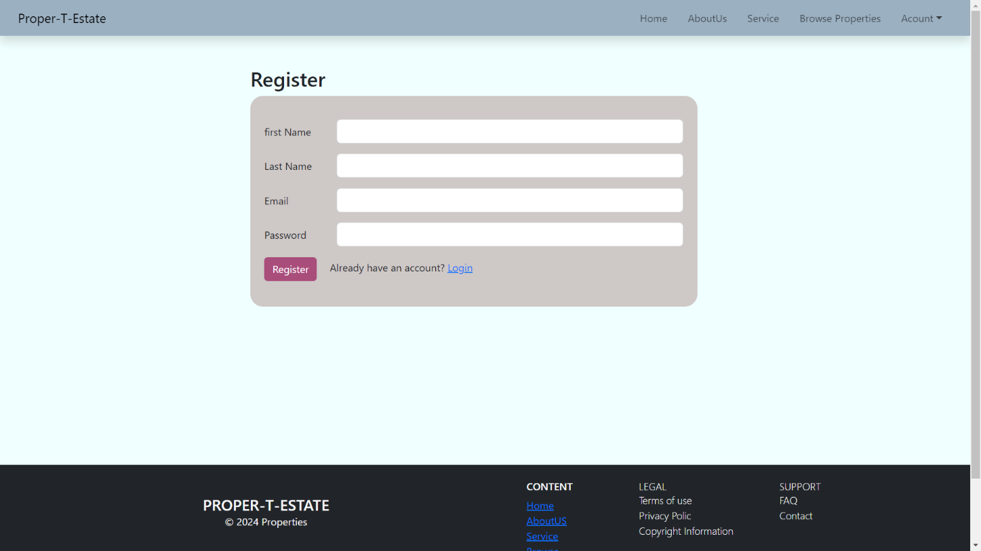

**g) Admin Page**

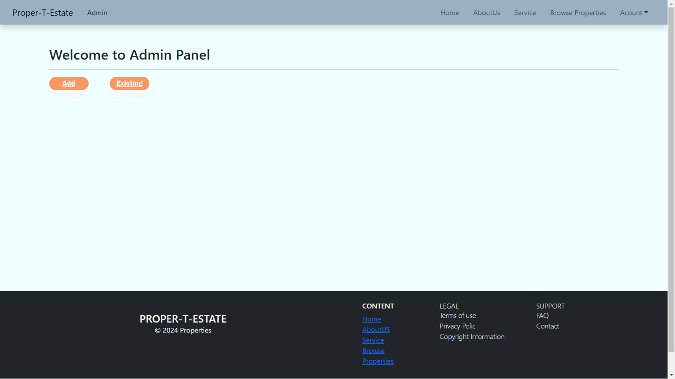

* **Add Property**

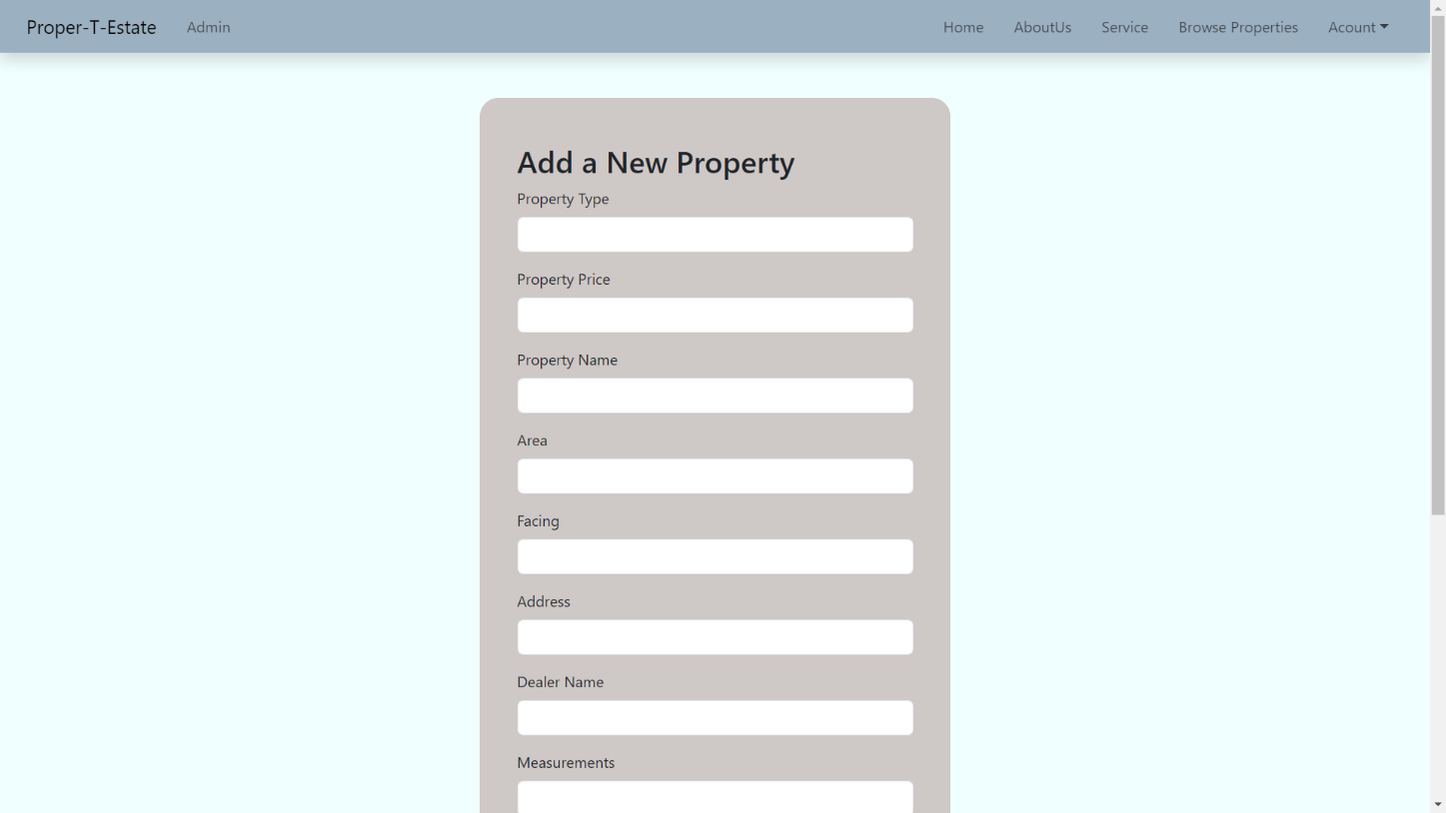

* **Existing Properties**

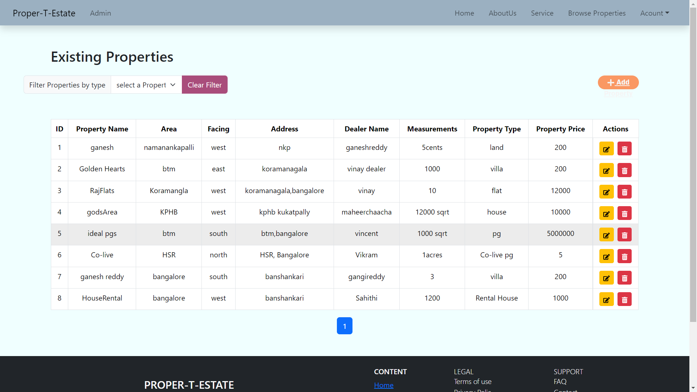

* **Exit Property**

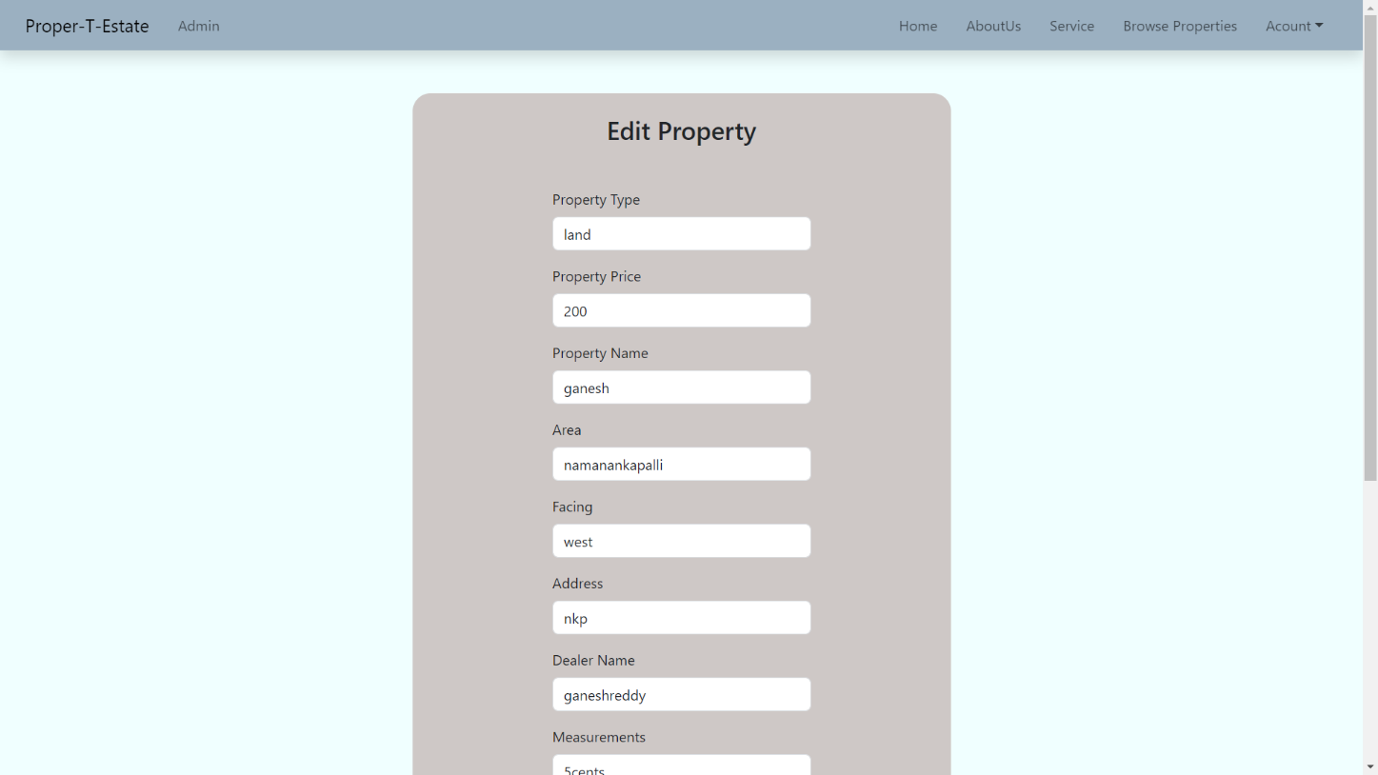

1. **Profile Page**

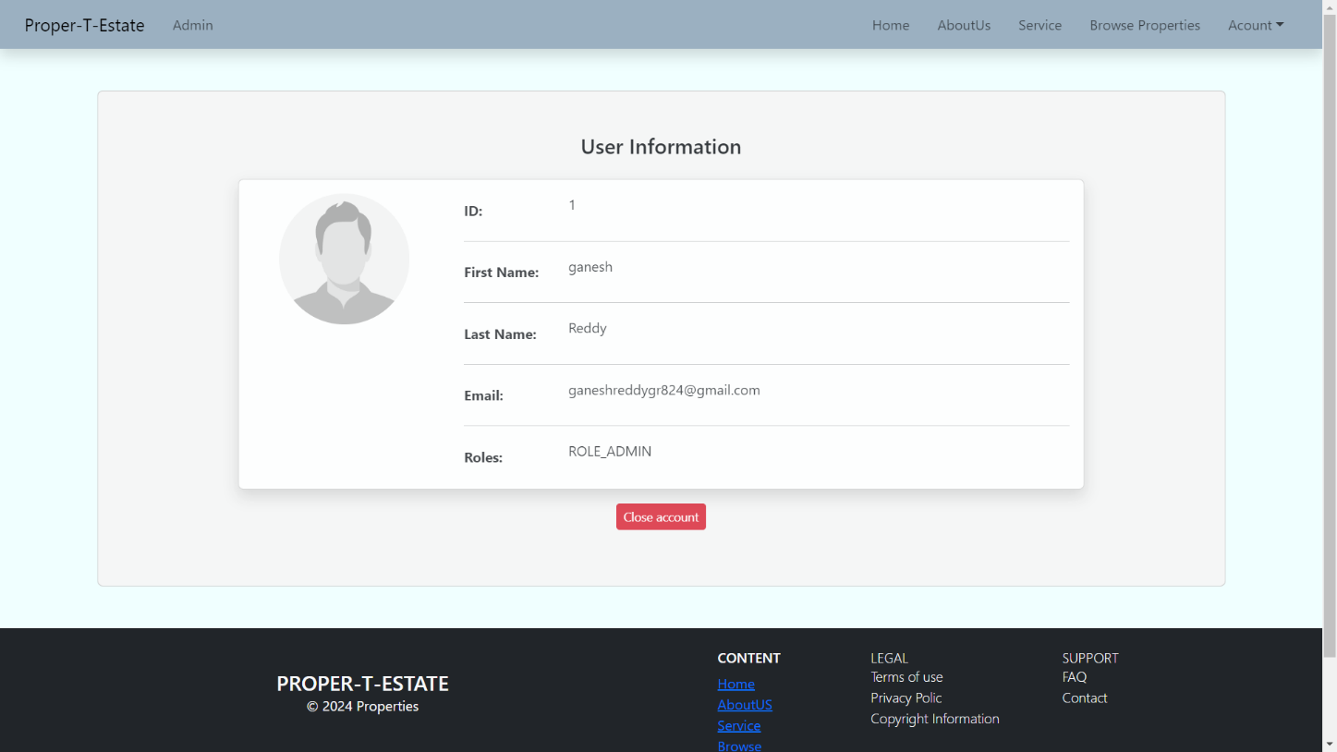

1. **GITHUB LINK**

**Link :** [**https://github.com/ganeshreddy824/Proper-T-Estate**](https://github.com/ganeshreddy824/Proper-T-Estate)